**Create High Availability Architecture with AWS CLI**

Create volume command: aws ec2 create-volume --availability-zone ap-south-1a --size 1

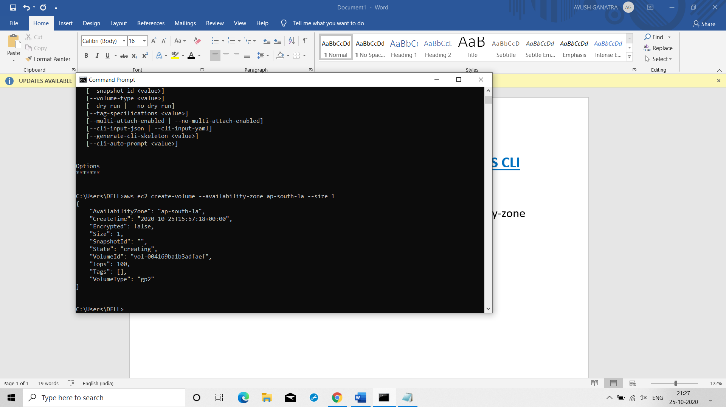

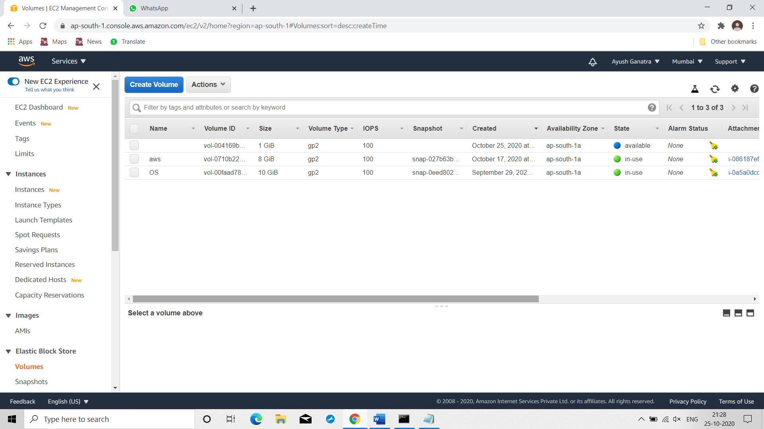

Attaching volume command: aws ec2 attach-volume --instance-id i-086187ef27fbdde29 --volume-id vol-004169ba1b3adfaef --device /dev/sdb

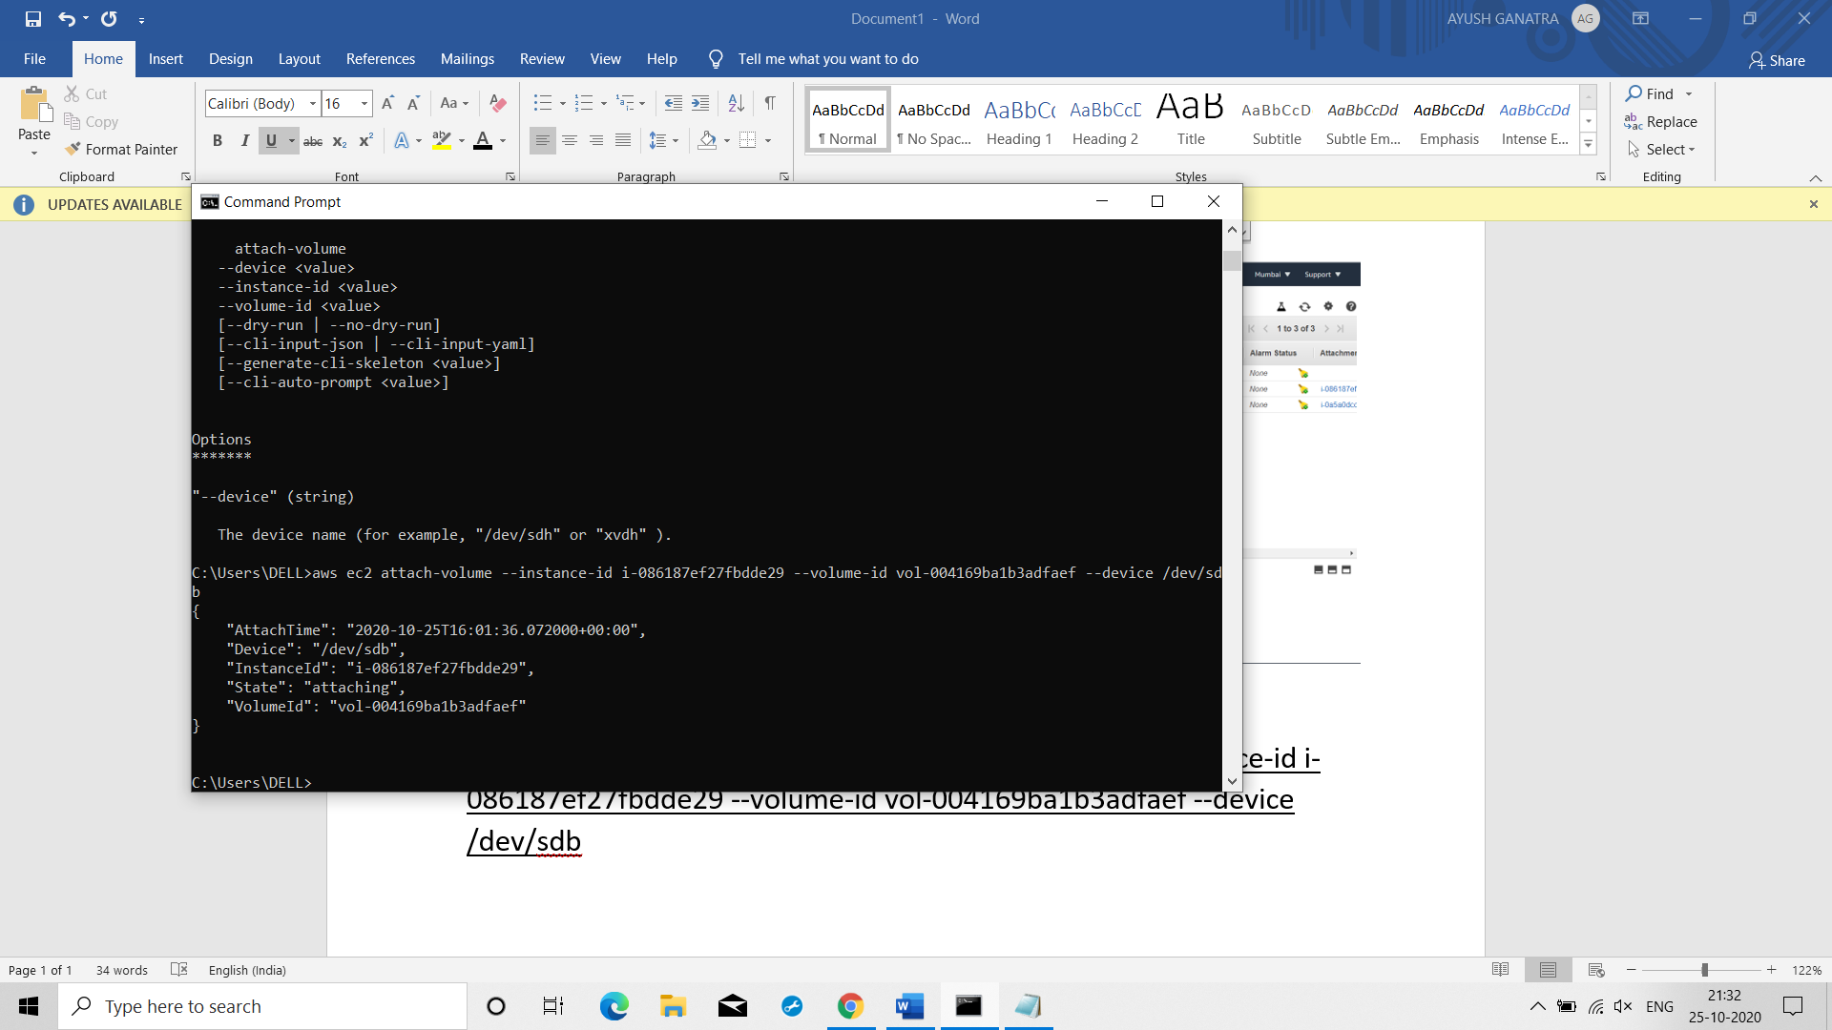

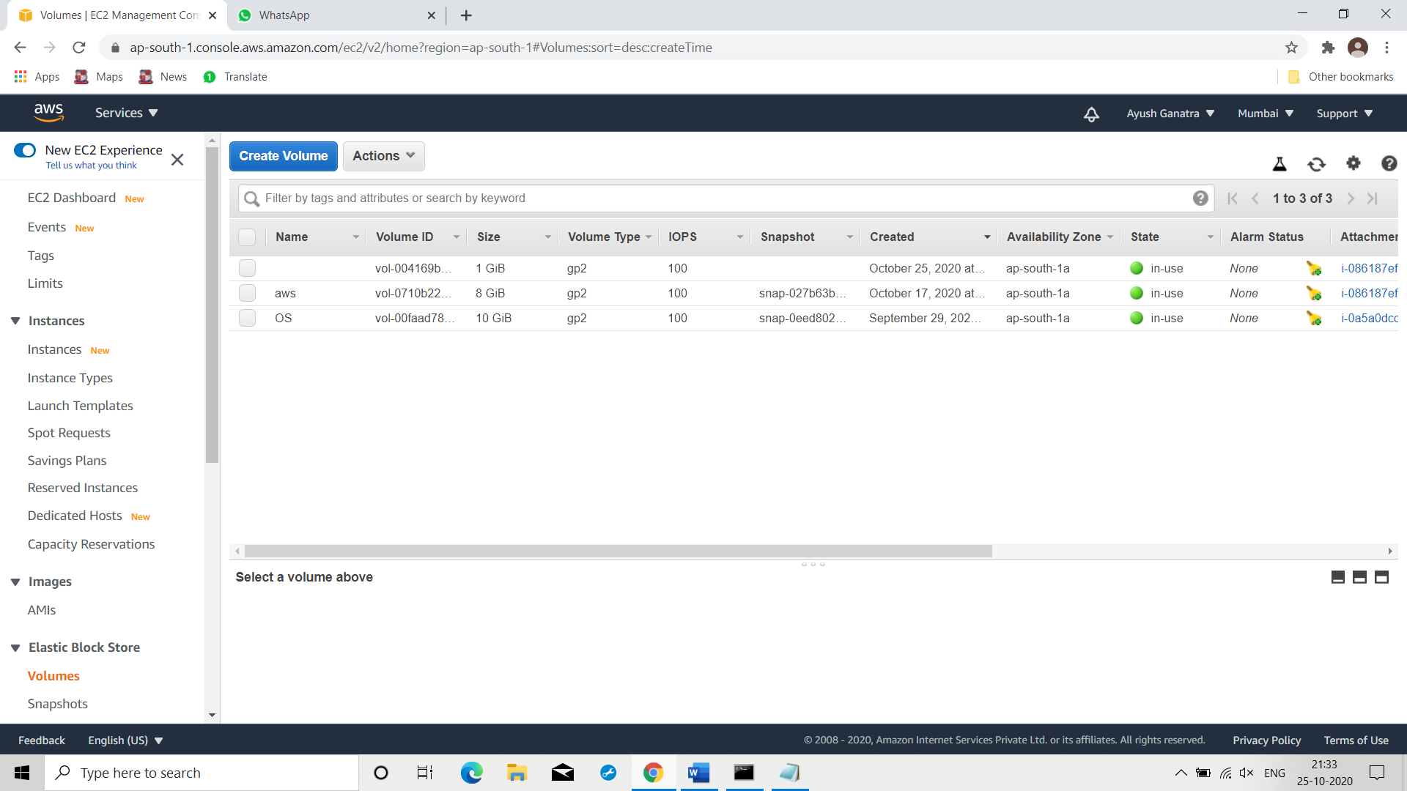

Creating partition:

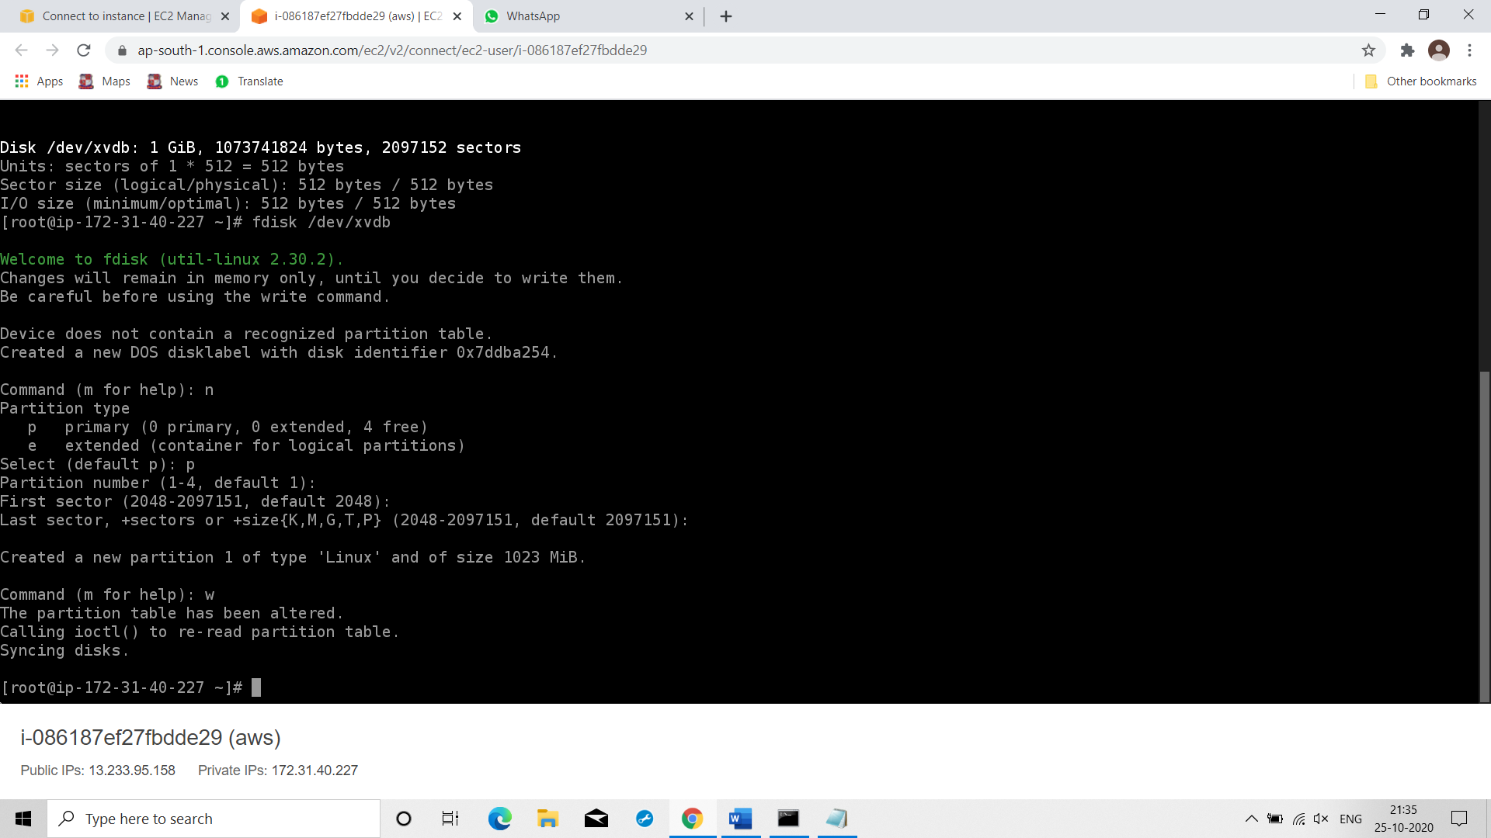

Formatting & Mounting /var/www/html folder:

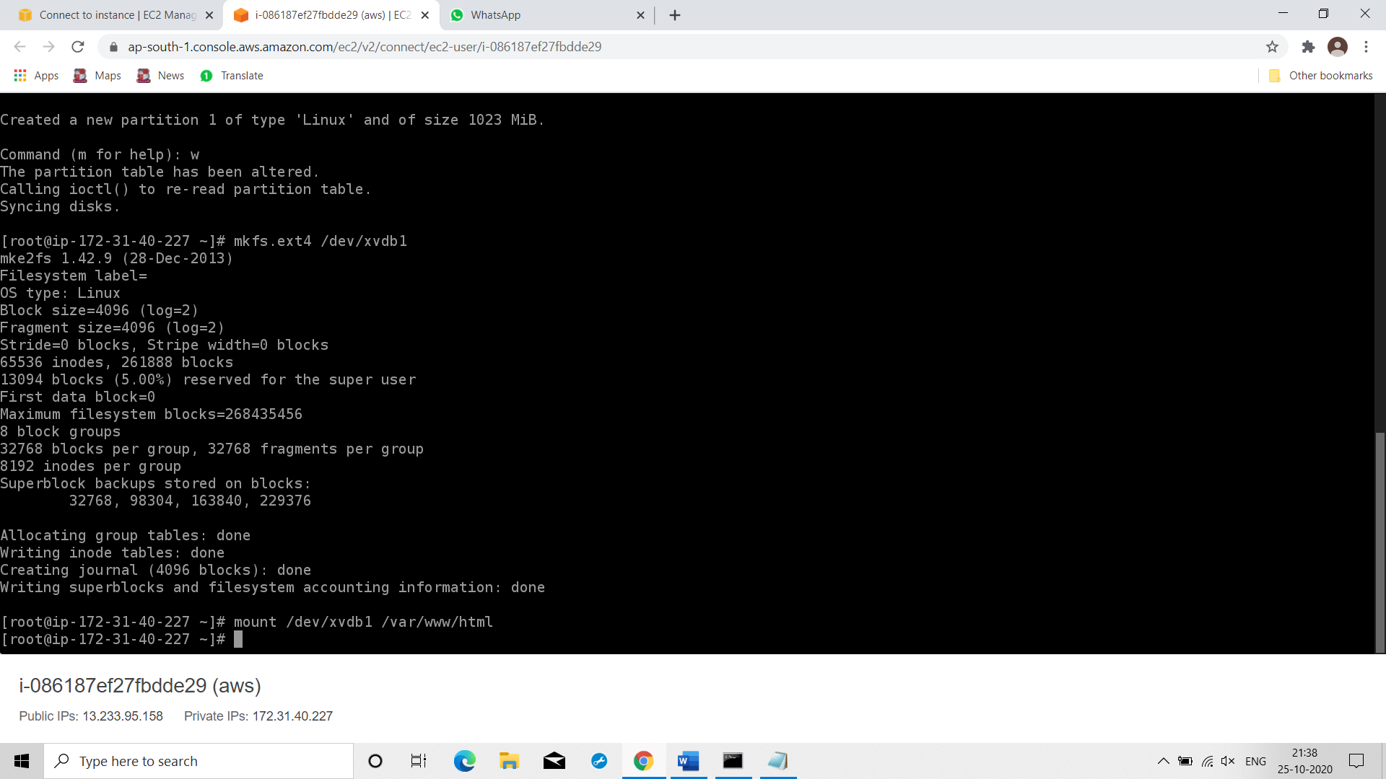

Starting https services command: systemctl start httpd

Creating S3 bucket command: aws s3 mb s3://ayushawsb1 --region ap-south-1

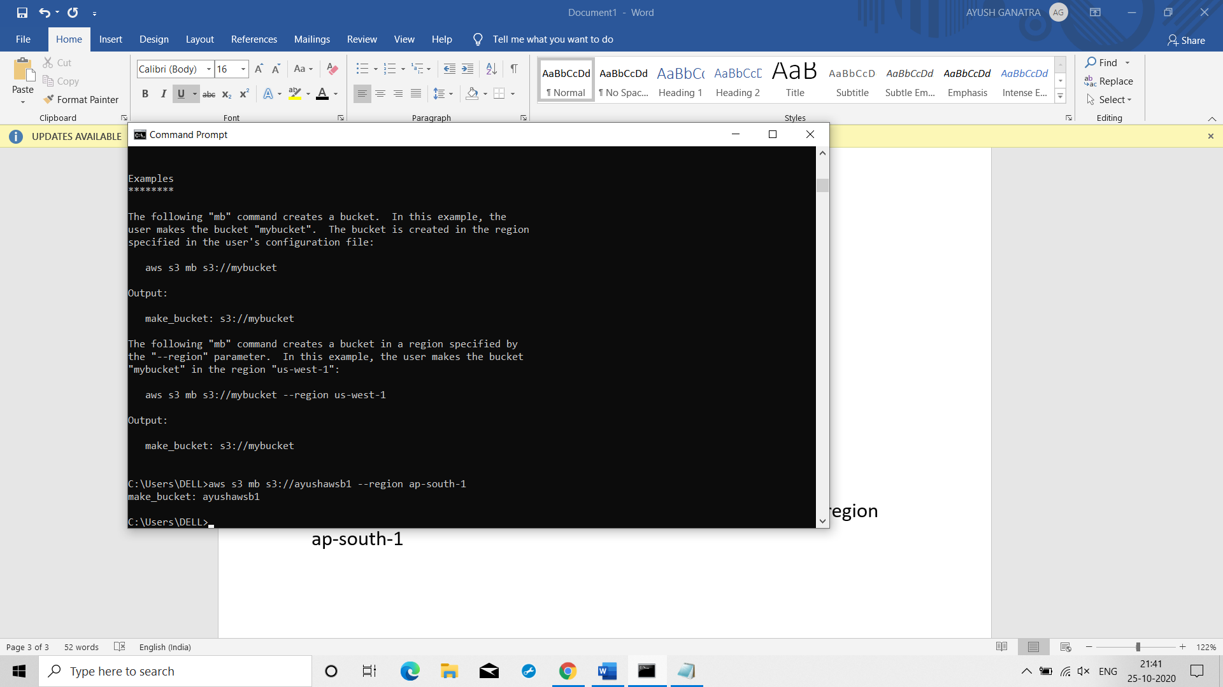

Creating website in which our static data is in s3:

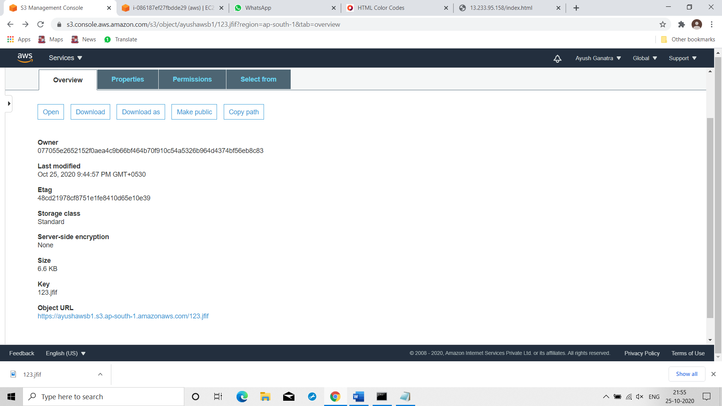

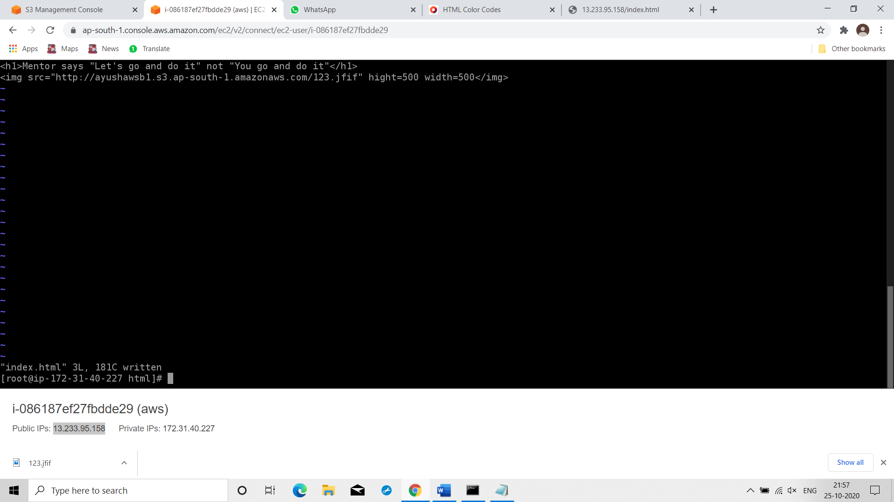



Creating cloud front distribution command: aws cloudfront create-distribution --origin-domain-name ayushawsb1.s3.amazonaws.com

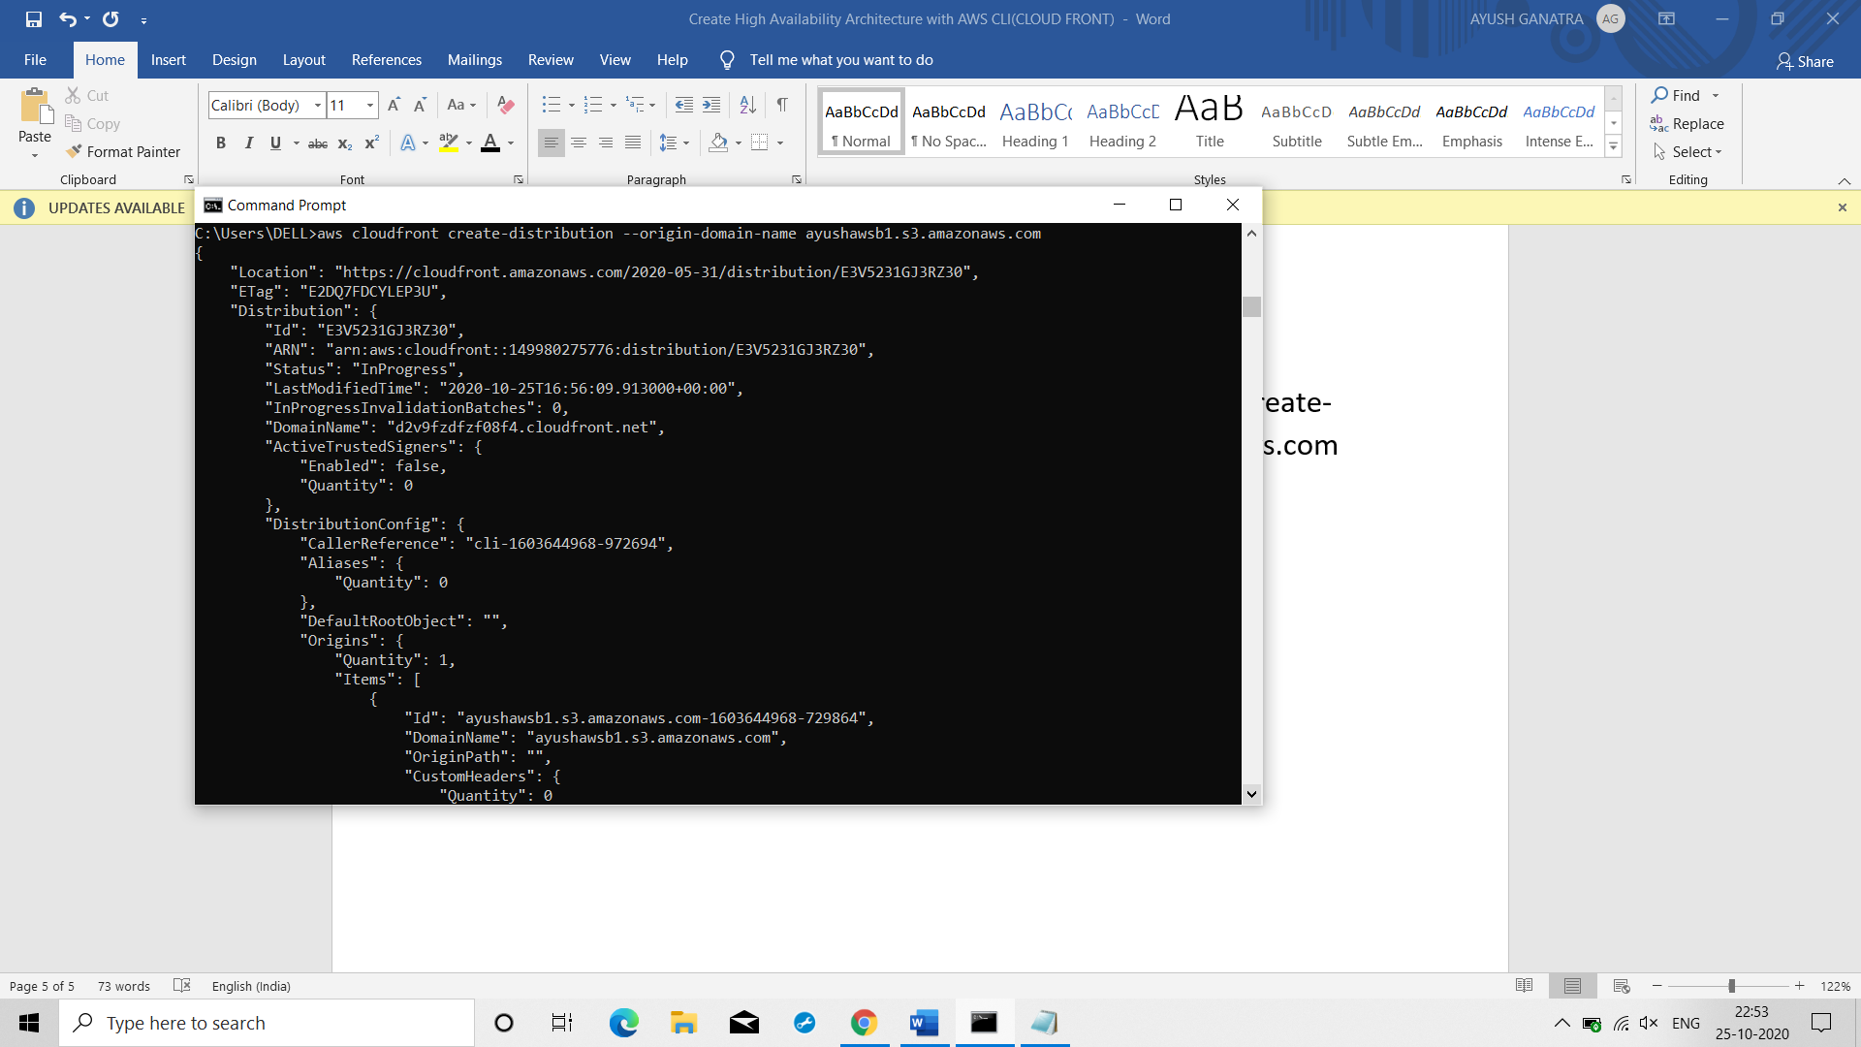

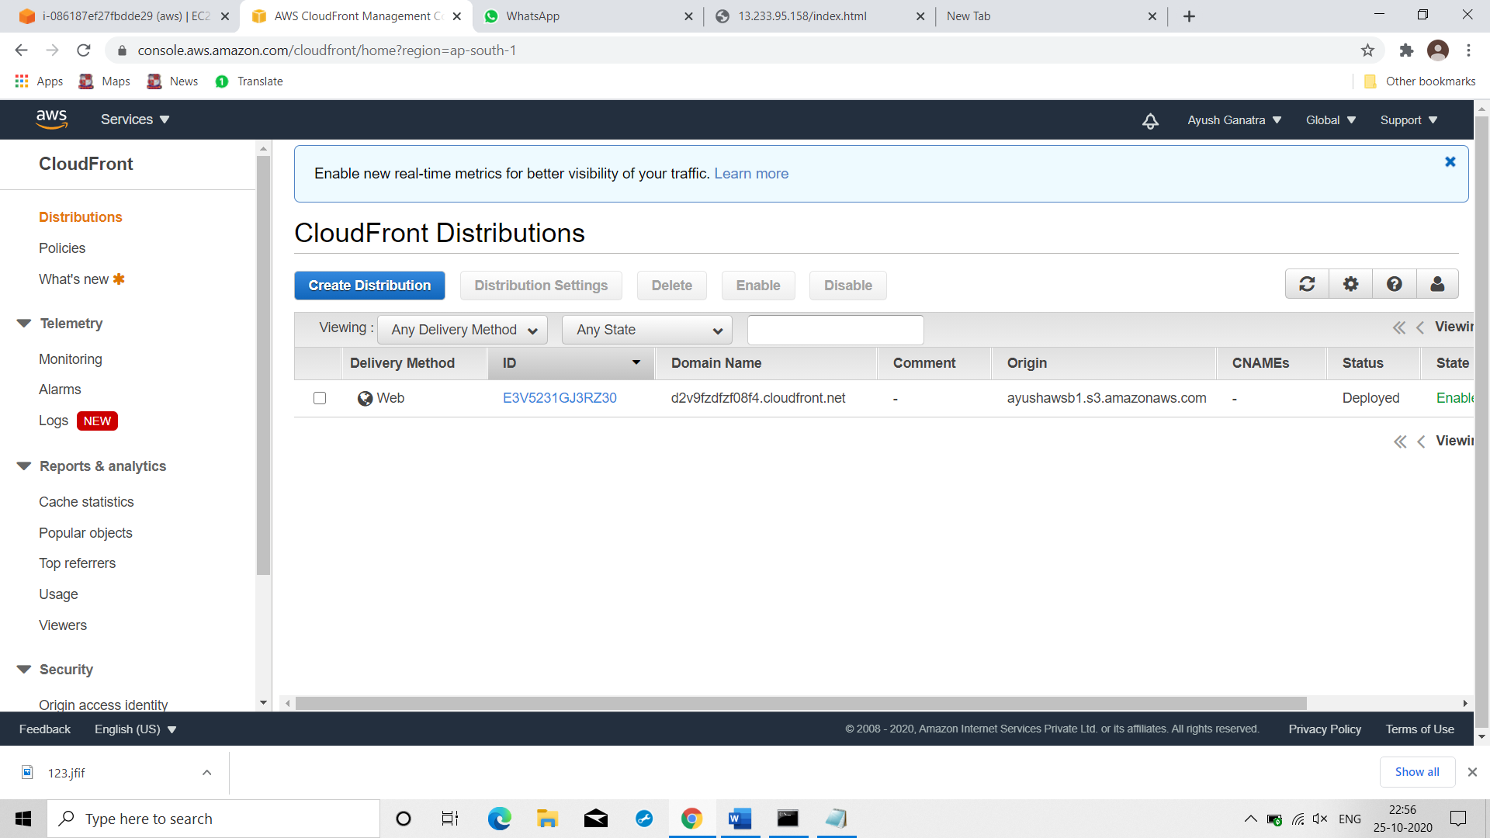

Giving this url/domain name to our website:

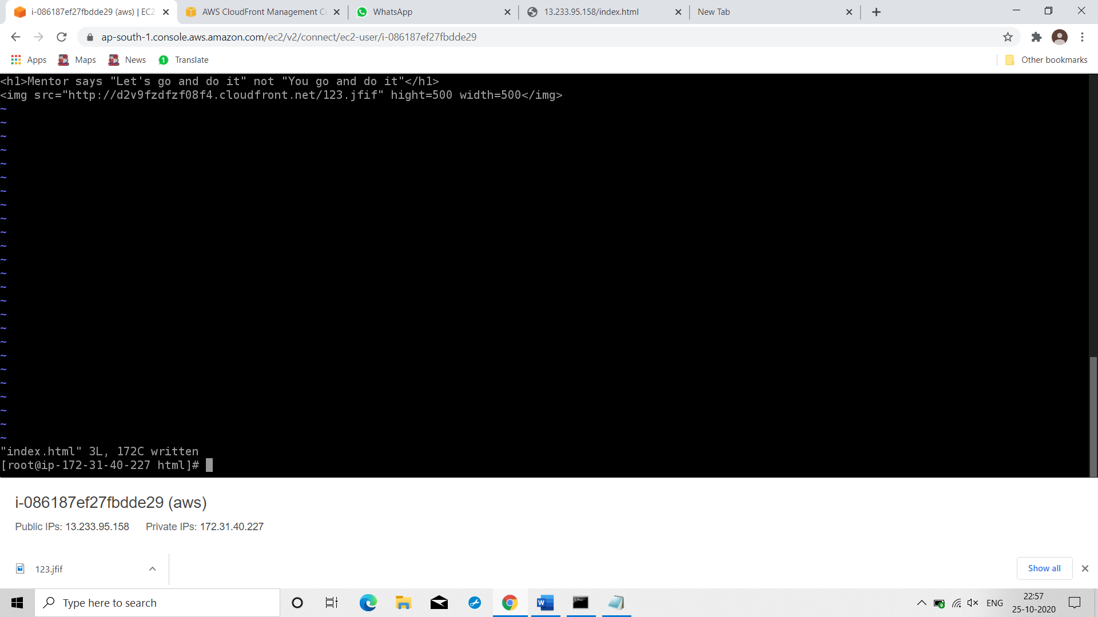

Now our data is stored in caches of edge location which would eventually reduce latency!!!